UNITED STATES

SECURITIES AND EXCHANGE COMMISSION
WASHINGTON, DC 20549

FORM 8-K

CURRENT REPORT

Pursuant to Section 13 or 15(d) of the Securities Exchange Act of 1934

Date of report (Date of earliest event reported): February 1, 2022

Enact Holdings, Inc.

(Exact name of registrant as specified in its charter)

Delaware | 001-40399 | 46-1579166
(State or other Jurisdiction of | (Commission | (IRS Employer
Incorporation) | File Number) | Identification No.)
 | 8325 Six Forks Road
 | Raleigh, North Carolina 27615
 | (919) 846-4100
 | (Address, including zip code, and telephone number, including area code, of registrant’s principal executive offices)

Check the appropriate box below if the Form 8-K filing is intended to simultaneously satisfy the filing obligation of the registrant under any of the following provisions (see General Instruction A.2. below):

- Written communications pursuant to Rule 425 under the Securities Act (17 CFR 230.425)

- Soliciting material pursuant to Rule 14a-12 under the Exchange Act (17 CFR 240.14a-12)
- Pre-commencement communications pursuant to Rule 14d-2(b) under the Exchange Act (17 CFR 240.14d-2(b))
- Pre-commencement communications pursuant to Rule 13e-4(c) under the Exchange Act (17 CFR 240.13e-4(c))

Securities registered pursuant to Section 12(b) of the Act:
Title of each class | Trading Symbol(s) | Name of each exchange on which registered
Common stock, par value $0.01 per share | ACT | The Nasdaq Stock Market

Indicate by check mark whether the registrant is an emerging growth company as defined in Rule 405 of the Securities Act of 1933 (§230.405 of this chapter) or Rule 12b-2 of the Securities Exchange Act of 1934 (§240.12b-2 of this chapter).

Emerging growth company ☐

If an emerging growth company, indicate by check mark if the registrant has elected not to use the extended transition period for complying with any new or revised financial accounting standards provided pursuant to Section 13(a) of the Exchange Act. ☐

Item 2.02 Results of Operations and Financial Condition.

On February 1, 2022, Enact Holdings, Inc. (the “Company”) issued (1) a press release announcing its financial results for the quarter ended December 31, 2021, a copy of which is attached hereto as Exhibit 99.1 and is incorporated herein by reference, and (2) a financial supplement for the quarter ended December 31, 2021, a copy of which is attached hereto as Exhibit 99.2 and is incorporated herein by reference.

The information contained in this Current Report on Form 8-K (including the exhibits) is being furnished and shall not be deemed “filed” for purposes of Section 18 of the Securities Exchange Act of 1934 (the “Exchange Act”) or otherwise subject to the liabilities under that Section and shall not be deemed to be incorporated by reference into any filing of the company under the Securities Act of 1933, as amended or the Exchange Act, except as shall be expressly set forth by specific reference in such filing. The information contained in this Current Report on Form 8-K shall not be incorporated by reference into any registration statement or other document pursuant to the Securities Act of 1933, as amended, or the Exchange Act, except as shall be expressly set forth by specific reference in any such filing.

Item 9.01 Financial Statements and Exhibits.

The following materials are furnished as exhibits to this Current Report on Form 8-K:

Exhibit

Number

99.1 | Press Release dated February 1, 2022
99.2 | Financial Supplement for the quarter ended December 31, 2021

- Cover Page Interactive Data File (the Cover Page Interactive Data File is embedded within the Inline XBRL document)

2

SIGNATURES

Pursuant to the requirements of the Securities Exchange Act of 1934, the registrant has duly caused this report to be signed on its behalf by the undersigned hereunto duly authorized.

Enact Holdings, Inc.
By: | /s/ Hardin Dean Mitchell
 | Name: | Hardin Dean Mitchell
 | Title: | Executive Vice President, Chief Financial Officer and Treasurer

Dated: February 1, 2022

3

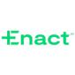
ENACT REPORTS FOURTH QUARTER AND FULL YEAR 2021 RESULTS

_______________________________________

Fourth quarter GAAP Net Income of $154 million, or $0.94 per diluted share

Full year GAAP Net Income of $547 million, or $3.36 per diluted share
Fourth quarter Adjusted Net Operating Income of $154 million, or $0.94 per diluted share
Full year Adjusted Net Operating Income of $551 million, or $3.38 per diluted share
Fourth quarter return on equity of 14.8% and adjusted operating return on equity of 14.8%
Book value per share of $25.21
Issued Dividend of $200 million in the fourth quarter
PMIERs Sufficiency of 165% or $2,003 million

Raleigh, NC, February 1, 2022 – Enact Holdings, Inc. (Nasdaq: ACT) today announced financial results for the fourth quarter and full year of 2021, ending December 31, 2021.

"We had an excellent fourth quarter driven by strong execution of our strategies, the benefits of our competitive position, and supportive industry fundamentals. With over $21 billion of new insurance written, record insurance-in-force, and favorable loss performance, this was a strong finish to a transformational year for our company,” said Rohit Gupta, President and CEO of Enact. “Looking ahead, market dynamics for our business remain favorable, and we are well positioned to build on our success. Our experienced team, differentiated solutions, strong relationships and approach to risk management and efficiency provide a strong foundation for continued growth and value creation for all of our stakeholders.”

Key Financial Highlights

(In millions, except per share data or otherwise noted) | 4Q21 | 3Q21 | 4Q20 | 2021 | 2020
Net Income (loss) | $154 | $137 | $91 | $547 | $370
Diluted Net Income (loss) per share | $0.94 | $0.84 | $0.56 | $3.36 | $2.27
Adjusted Operating Income (loss) | $154 | $137 | $92 | $551 | $373
Adj. Diluted Operating Income (loss) per share | $0.94 | $0.84 | $0.57 | $3.38 | $2.29
NIW ($B) | $21.4 | $24.0 | $27.0 | $97.0 | $99.9
Primary IIF ($B) | $227 | $222 | $208
Persistency | 69% | 65% | 57% | 62% | 59%
Net Premiums Earned | $237 | $243 | $251 | $975 | $971
Losses Incurred | $6 | $34 | $89 | $125 | $380
Loss Ratio | 3% | 14% | 35% | 13% | 39%
Operating Expenses | $59 | $59 | $69 | $246 | $236
Expense Ratio | 25% | 24% | 28% | 25% | 24%
Net Investment Income | $35 | $36 | $35 | $141 | $133
Return on Equity | 14.8% | 13.2% | 9.5% | 13.7% | 9.6%
Adjusted Operating Return on Equity | 14.8% | 13.2% | 9.7% | 13.8% | 9.7%
PMIERs Sufficiency ($) | $2,003 | $2,287 | $1,229
PMIERs Sufficiency (%) | 165% | 181% | 137%

1

Fourth Quarter 2021 Financial and Operating Highlights

- Net income for the fourth quarter of 2021 was $154 million, or $0.94 per diluted share, compared with $137 million, or $0.84 per diluted share, for the third quarter of 2021 and $92 million, or $0.56 per diluted share, for the fourth quarter of 2020. The sequential improvement in net income in the current quarter was primarily driven by lower losses from favorable reserve development, partially offset by lower premiums. The increase in net income from the fourth quarter of 2020 was primarily driven by lower losses from favorable reserve development in the current quarter and lower new delinquencies in the current quarter as well as unfavorable reserve development in fourth quarter of 2020, offset partially by lower premiums in the current quarter.
- Adjusted net operating income for the fourth quarter of 2021 was $154 million, or $0.94 per diluted share, compared with $137 million, or $0.84 per diluted share, for the third quarter of 2021 and $91 million, or $0.57 per diluted share, for the fourth quarter of 2020.
- New insurance written (NIW) was $21.4 billion, down 11% compared to $24.0 billion in the third quarter of 2021, driven by lower estimated originations and down 21% compared to $27.0 billion in the fourth quarter of 2020 driven by lower refinancing activity. Our new insurance written for the fourth quarter was comprised of 91% monthly premium policies and 90% purchase originations.
- Primary Insurance-In-Force was $227 billion, up 2% compared to $222 billion in the third quarter of 2021 and up 9% compared to $208 billion in the fourth quarter of 2020.
- Persistency for the fourth quarter of 2021 was 69%, up from 65% in the third quarter of 2021 and 57% in the fourth quarter of 2020. The increase in persistency was primarily driven by an uptick in mortgage rates and a continued decline in the percentage of our in-force policies with mortgage rates above current rates. Persistency remains below the historical norm of approximately 80%.
- Net premiums earned were $237 million, down 3% compared to $243 million in the third quarter of 2021 and down 6% compared to $251 million in the fourth quarter of 2020. Net earned premium yield was down from the third quarter of 2021 and the fourth quarter of 2020, driven by lower single premium cancellations and the lapse of older, higher-priced policies as compared to our new insurance written. The decrease in net earned premium yield versus the fourth quarter 2020 was also driven by higher ceded premiums in the current quarter.
- Losses incurred for the fourth quarter of 2021 were $6 million and the loss ratio was 3%, compared to $34 million and 14%, respectively, in the third quarter of 2021, driven by favorable reserve development in the current quarter of $32 million, partially offset by higher new delinquencies from natural disasters in FEMA-impacted areas and recent large books entering their expected loss development pattern. Current quarter losses incurred and the loss ratio also compared favorably to results of the fourth quarter 2020 of $89 million and 35%, respectively, driven by favorable reserve development of $32 million and lower new delinquencies in the current quarter, as well as unfavorable reserve development of $37 million in the fourth quarter of 2020.
- Percentage of loans in default at quarter end was 2.6%, compared to 3.1% as of September 30, 2021, and 4.9% as of December 30, 2020, as cures continued to outpace new delinquencies for the sixth consecutive quarter.
- Operating expenses in the current quarter were $59 million, and the expense ratio was 25%, compared to $59 million and 24%, respectively, in the third quarter of 2021, driven by incremental expenses associated with standing-up certain public company activities and lower premiums. Operating expenses and the expense ratio were $69 million and 28%, respectively, in the fourth quarter of 2020. Current-quarter operating expenses include $1 million of strategic transaction preparation costs and restructuring costs that are not expected to recur in future periods, as compared to $3 million in the third quarter of 2021.
- Net investment income for the quarter was $35 million, compared to $36 million in the third quarter of 2021 and $35 million in the fourth quarter of 2020.

2

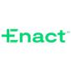
- Annualized return on equity for the fourth quarter of 2021 was 14.8%, and annualized adjusted operating return on equity was 14.8%. Current-quarter results compare favorably to both the third quarter 2021 results of 13.2% and 13.2% and the fourth quarter 2020 results of 9.5% and 9.7%, respectively. Sequential improvements in both return on equity and adjusted
operating return on equity were driven, in part, by the execution of a $200 million special cash dividend in the current quarter, as well as lower unrealized gains in our asset portfolio.

- PMIERs sufficiency was 165% and $2,003 million above the published PMIERs requirements compared to 181% and $2,287 million above the published PMIERs requirements in the third quarter of 2021. The sequential decline in PMIERs sufficiency was driven by our $200 million dividend, NIW and the amortization of existing reinsurance transactions, partially offset by elevated lapse from prevailing low interest rates, business cash flows, and lower delinquencies.

- PMIERs sufficiency benefited from a 0.30 multiplier applied to the risk-based required asset factor for certain non-performing loans, which resulted in a reduction of the published PMIERs required assets by an estimated $390 million at the end of the current quarter, compared to $570 million at the end of the third quarter 2021 and $1,046 million at the end of the fourth quarter 2020. These amounts are gross of incremental reinsurance benefits from the elimination of the 0.30 multiplier.
- Enact Holdings, Inc. held $264 million of cash as of December 31, 2021, a decrease of $29 million from the prior quarter, primarily due to the completion of our purchase of our Parent’s minority interest in a mortgage guarantee business in India.

Recent Events

- In January 2022, we executed an excess-of-loss reinsurance transaction with a panel of reinsurers, which provides up to $294 million of reinsurance coverage on a portion of current and expected new insurance written for the 2022 book year.

Conference Call and Financial Supplement Information

This press release and the fourth quarter 2021 financial supplement are now posted on the Company’s website, https://ir.enactmi.com. Additional information regarding business results will be posted on the Company's website, by 8:00 a.m. on February 2, 2022. Investors are encouraged to review these materials.

Enact will discuss fourth quarter and full year 2021 financial results in a conference call tomorrow, Wednesday, February 2, 2022, at 8:00 a.m. (Eastern). Enact’s conference call can be accessed via telephone and Internet. The dial-in number is 1.833.730.3978 in the U.S. or 1.720.405.2123 for international callers; the conference ID is 7969025. To participate in the call by webcast, register at https://ir.enactmi.com/news-and-events/events at least 15 minutes prior to the webcast to download and install any necessary software.

A digital replay of the webcast will be available on the Enact website following the live broadcast for a period of one year at https://ir.enactmi.com/news-and-events/events.

In addition to the information provided in the company's earnings news release, other statistical and financial information, which is expected to be referred to during the conference call, is available on Enact’s website at https://ir.enactmi.com.

3

About Enact

Enact Holdings, Inc. (Nasdaq: ACT), operating principally through its wholly owned subsidiary Genworth Mortgage Insurance Corp. since 1981, is a leading U.S. private mortgage insurance provider committed to helping more people achieve the dream of homeownership. Building on a deep understanding of lenders' businesses and a legacy of financial strength, we partner with lenders to bring best-in class service, leading underwriting expertise, and extensive risk and capital management to the mortgage process, helping to put more people in homes and keep them there. By empowering customers and their borrowers, Enact seeks to positively impact the lives of those in the communities in which it serves in a sustainable way. Enact is headquartered in Raleigh, North Carolina.

Safe Harbor Statement

This communication contains “forward-looking statements” within the meaning of the Private Securities Litigation Reform Act. These forward-looking statements may address, among other things, our expected financial and operational results, the related assumptions underlying our expected results, and the quotations of management. These forward-looking statements are distinguished by use of words such as “will,” “would,” “anticipate,” “expect,” “believe,” “designed,” “plan,” or “intend,” the negative of these terms, and similar references to future periods. These views involve risks and uncertainties that are difficult to predict and, accordingly, our actual results may differ materially from the results discussed in our forward-looking statements. Our forward-looking statements contained herein speak only as of the date of this press release. Factors or events that we cannot predict, including uncertainty around Covid-19 and the effects of government and other measures seeking to contain its spread, risks related to an economic downturn or recession in the United States and in other countries around the world, changes in political, business, regulatory, and economic conditions and other factors described in the risk factors contained in our filings with the Securities and Exchange Commission, may cause our actual results to differ from those expressed in forward-looking statements. Although Enact believes the expectations reflected in such forward-looking statements are based on reasonable assumptions, the Company can give no assurance that its expectations will be achieved and it undertakes no obligation to update publicly any forward-looking statements as a result of new information, future events, or otherwise, except as required by applicable law.

GAAP/Non-GAAP Disclosure Discussion

This communication includes the non-GAAP financial measures entitled “adjusted operating income (loss)”, “adjusted operating income (loss) per share", and “adjusted operating return on equity." Adjusted operating income (loss) per share is derived from adjusted operating income (loss). The chief operating decision maker evaluates performance and allocates resources on the basis of adjusted operating income (loss). The Company defines adjusted operating income (loss) as net income (loss) excluding the after-tax effects of net investment gains (losses), restructuring costs and infrequent or unusual non-operating items. The Company excludes net investment gains (losses) and infrequent or unusual non-operating items because the company does not consider them to be related to the operating performance of the company and other activities. The recognition of realized investment gains or losses can vary significantly across periods as the activity is highly discretionary based on the timing of individual securities sales due to such factors as market opportunities or exposure management. Trends in the profitability of our fundamental operating activities can be more clearly identified without the fluctuations of these realized gains and losses. We do not view them to be indicative of our fundamental operating activities. Therefore, these items are excluded from our calculation of adjusted operating income. In addition, adjusted operating income (loss) per share is derived from adjusted operating income (loss) divided by shares outstanding. Adjusted operating return on equity is calculated as annualized adjusted operating income for the period indicated divided by the average of current period and prior periods’ ending total stockholders’ equity.

While some of these items may be significant components of net income (loss) in accordance with U.S. GAAP, the company believes that adjusted operating income (loss) and measures that are derived from

4

or incorporate adjusted operating income (loss), including adjusted operating income (loss) per share on a basic and diluted basis and adjusted operating return on equity, are appropriate measures that are useful to investors because they identify the income (loss) attributable to the ongoing operations of the business. Management also uses adjusted operating income (loss) as a basis for determining awards and compensation for senior management and to evaluate performance on a basis comparable to that used by analysts. Adjusted operating income (loss) and adjusted operating income (loss) per share on a basic and diluted basis are not substitutes for net income (loss) available to Enact Holdings, Inc.’s common stockholders or net income (loss) available to Enact Holdings, Inc.’s common stockholders per share on a basic and diluted basis determined in accordance with U.S. GAAP. In addition, the company’s definition of adjusted operating income (loss) may differ from the definitions used by other companies.

Adjustments to reconcile net income (loss) available to Enact Holdings, Inc.’s common stockholders to adjusted operating income (loss) assume a 21% tax rate.

5

Exhibit A: Consolidated Statements of Income
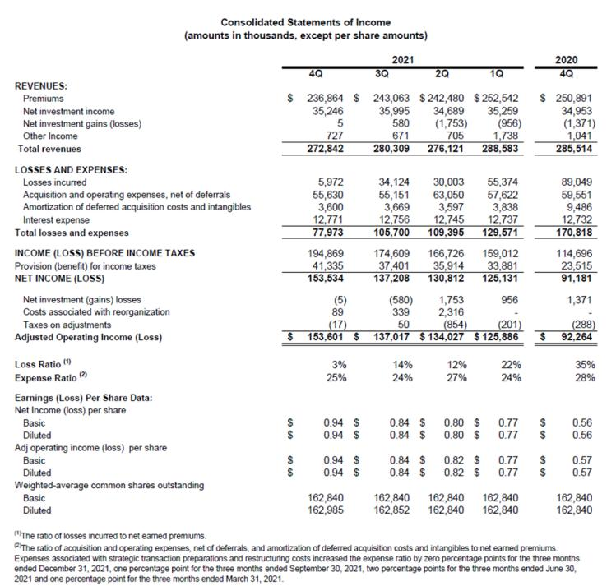

6

Exhibit B: Consolidated Balance Sheets
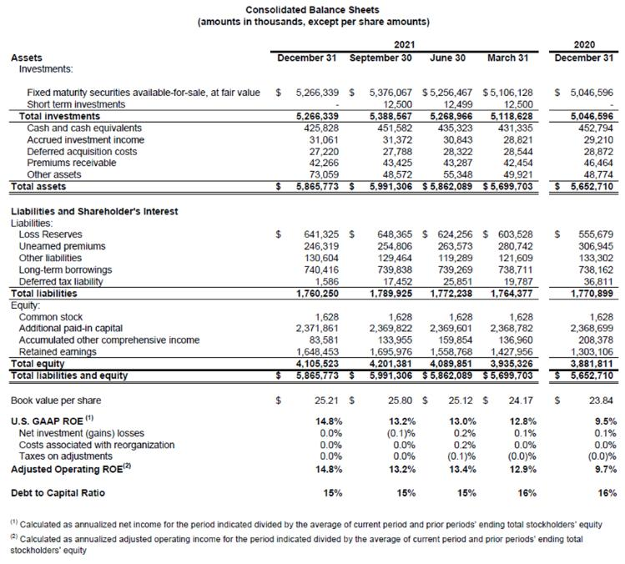

7



